***Upload projects to GitHub***

1. Creating new repository - **GIT_Practice**

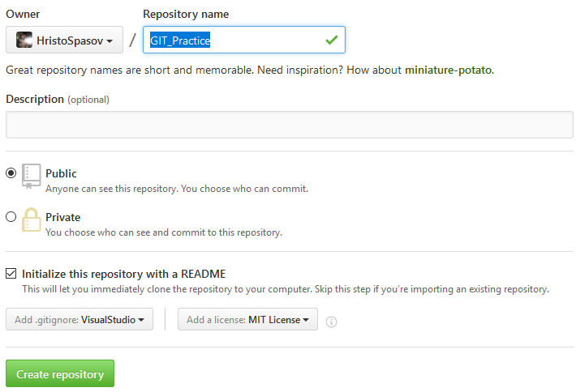

1. Clone repository with TortoiseGit

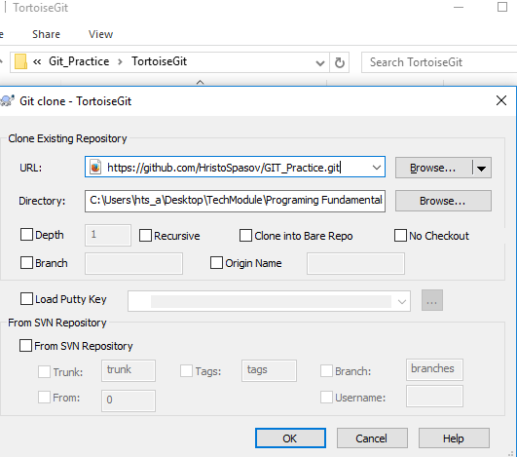

Report from TortoiseGit

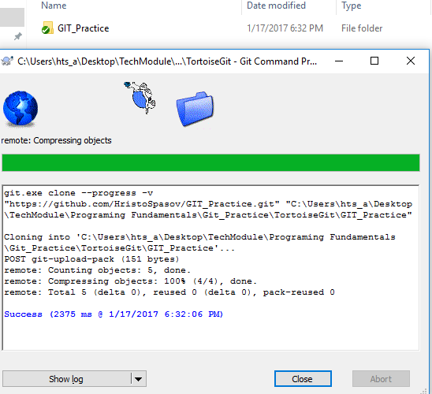

1. Clone the same repository with GitBash

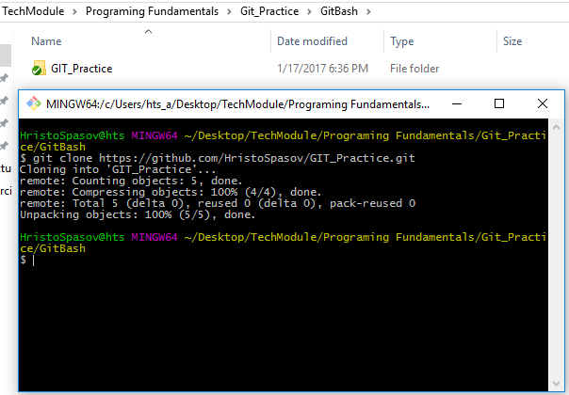

1. Add new file in TortoiseGit folder

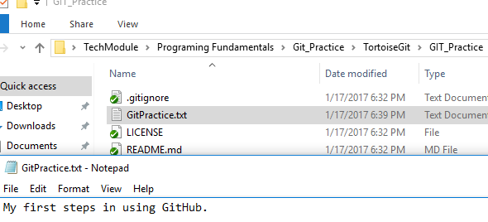

1. Commit changes with TortoiseGit

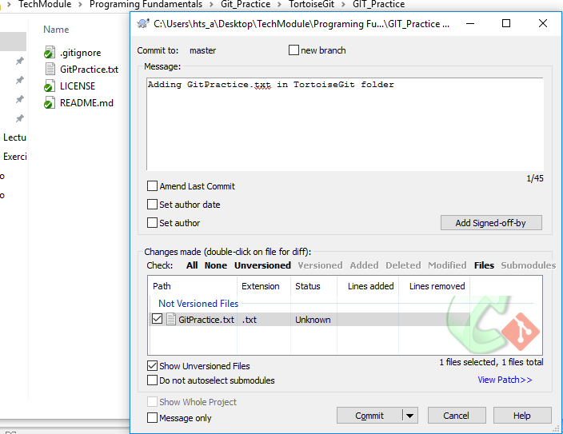

1. Report after push changes from PC to Cloud, using TortoiseGit

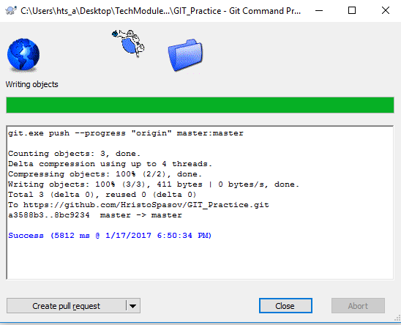

New file is synced with GitHub

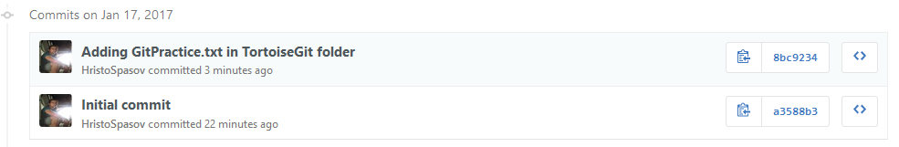

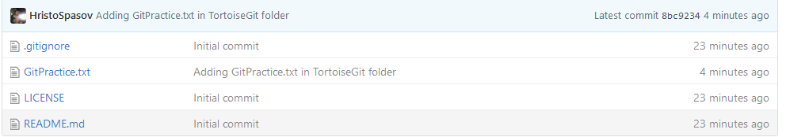

***Make Conflicts and Resolve Them***

1. Make changes in Readme.md file in tortoise folder

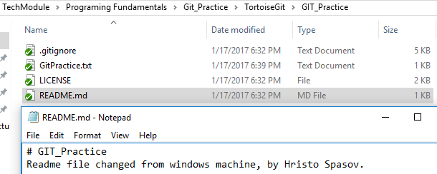

1. Make changes in Readme.md file in GitHub and commit changes

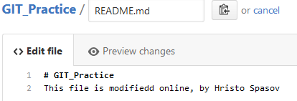

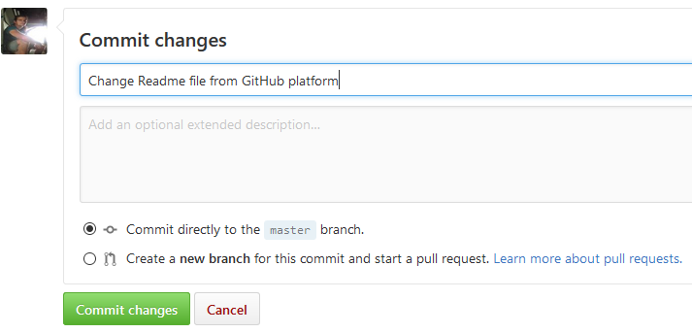

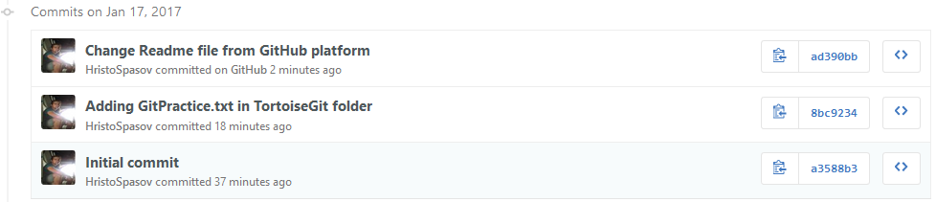

1. Commit changes in TortoiseGit

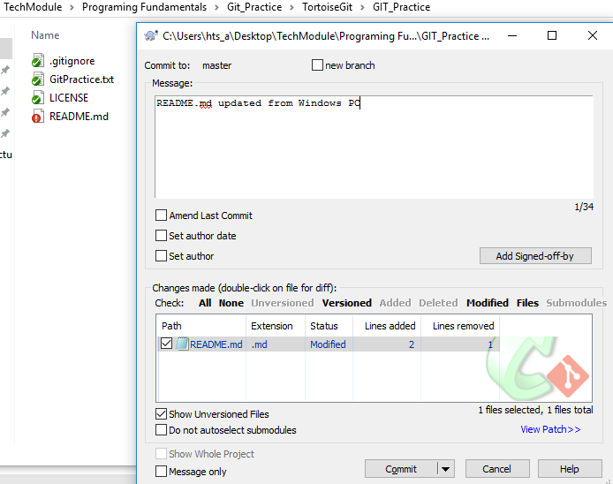

Commit report from TortoiseGit

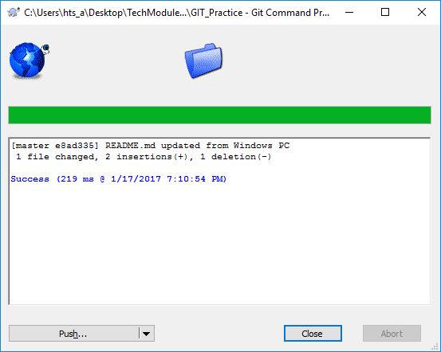

1. Push changes to GitHub using TortoiseGit

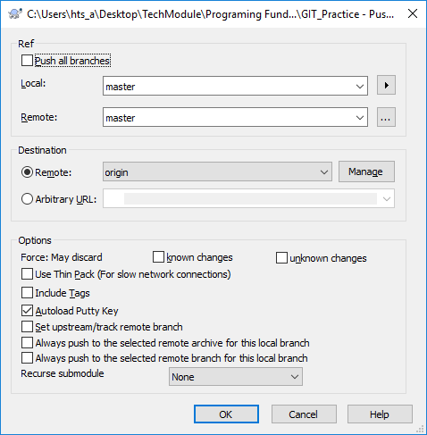

1. Push report fail

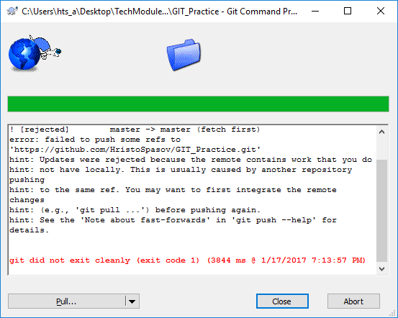

1. Making Pull from GitHub

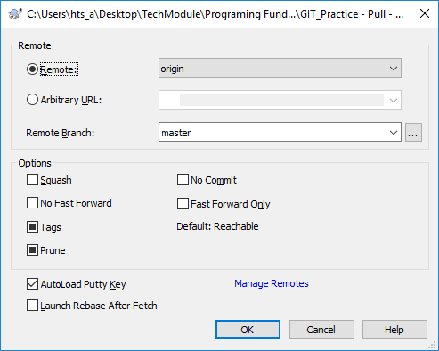

1. Pull report states the merge failed. We have fix the issues manually

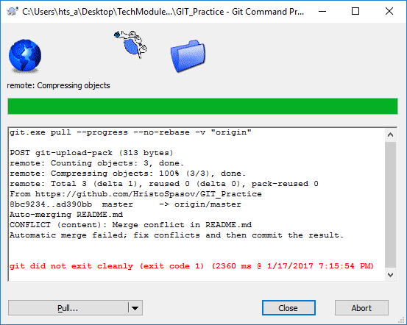

1. Showing file before and after the fix

Before the fix Readme looks like:

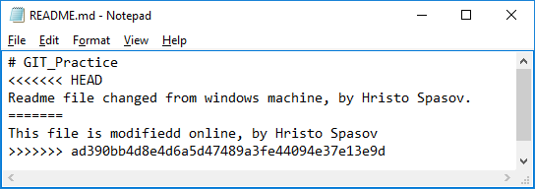

After the fix Readme looks like:

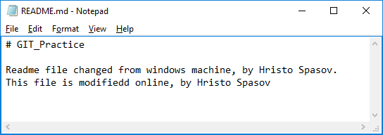

1. Resolving Readme file using TortoiseGit -> Resolve command

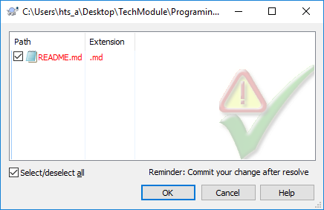

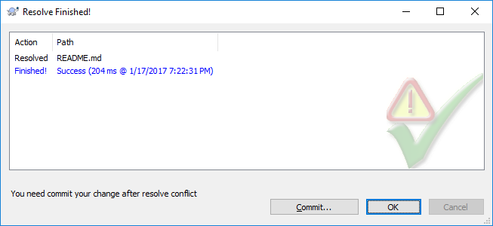

1. Commit changes to web

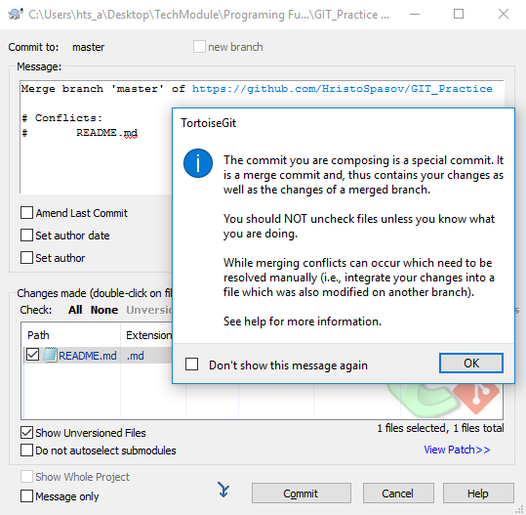

Commit report is successful

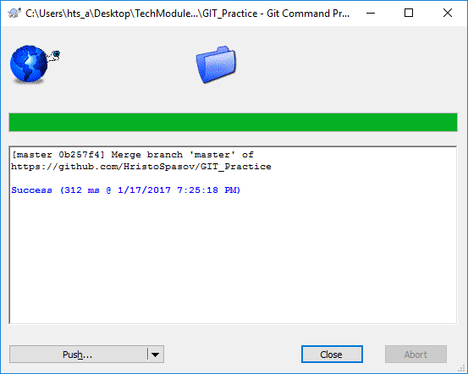

Push report is successful

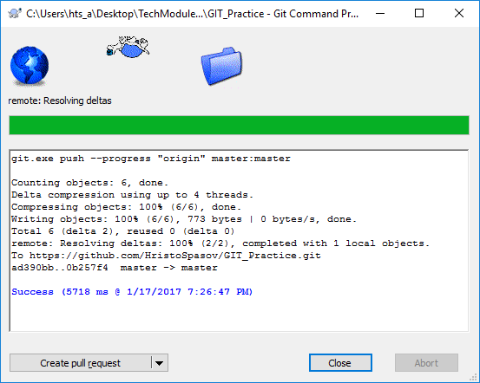

Updates after merge are present in GitHub system

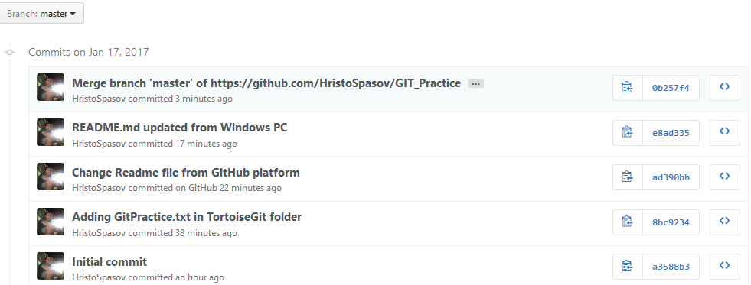

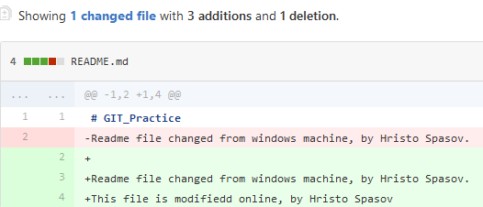

## *Create a branch and merge changes to the both local and remote repository*

1. Creating new branch

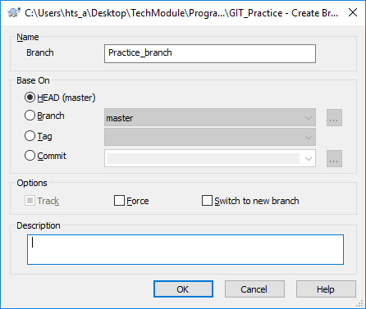

1. Switching to new branch

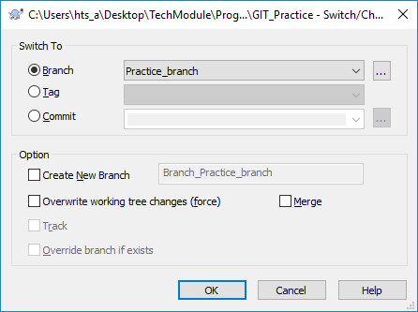

Report after switching 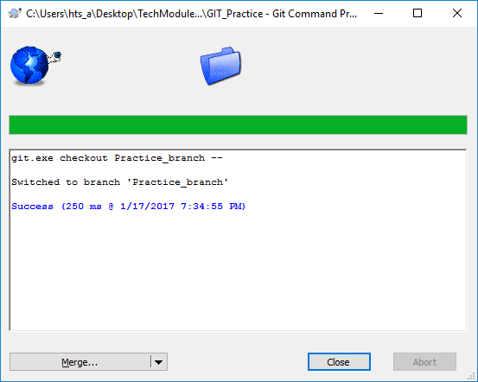

1. Making changes to the GitPractice file

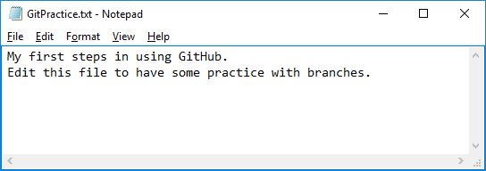

1. Making commit to Practice_branch

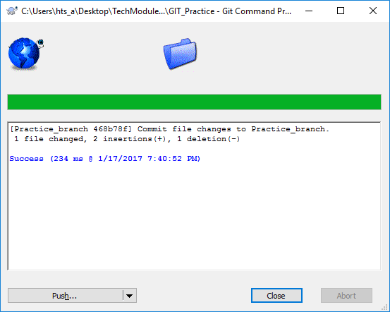

1. Switch back to Master branch, making changes to Practice file.

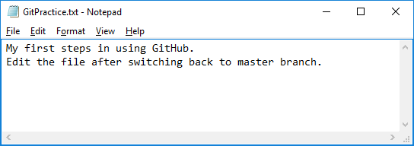

1. Commit file changes to master branch

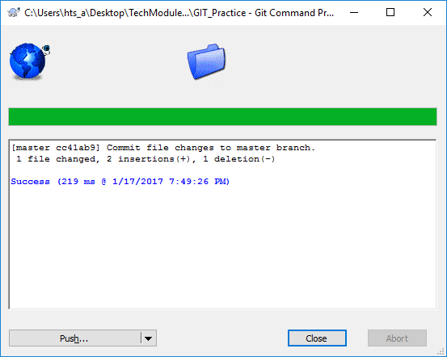

1. File changes from the master branch successfully pushed to GitHub

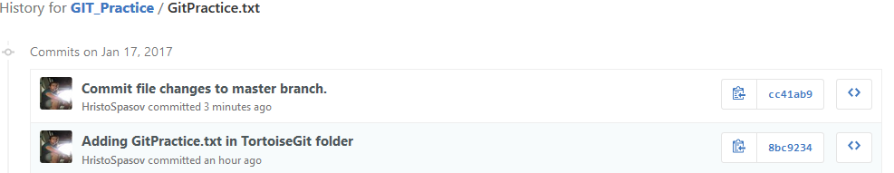

1. Merge failed

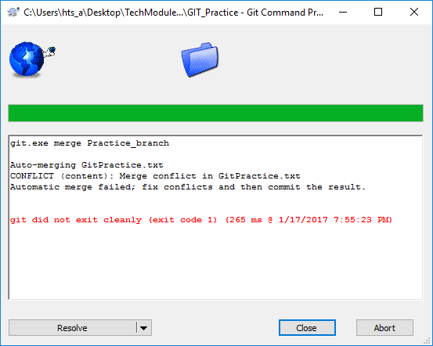

1. Resolving the conflict manually

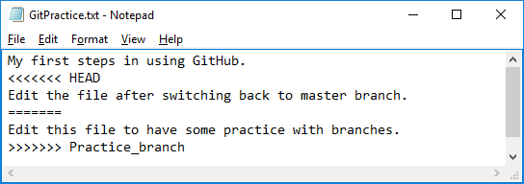

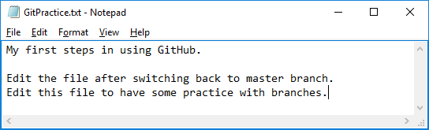

1. Commit changes

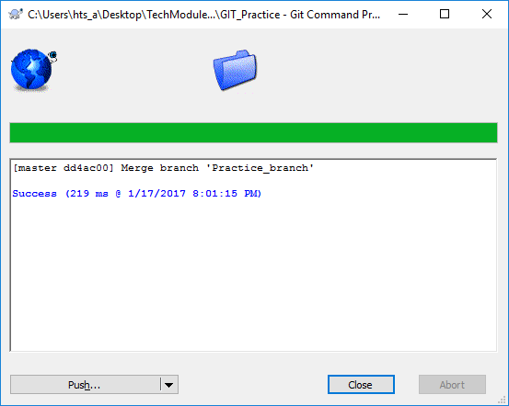

1. Push changes to GitHub successfull

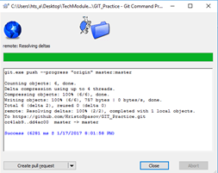

1. Both branches are merged

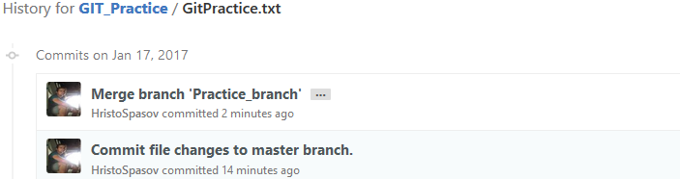

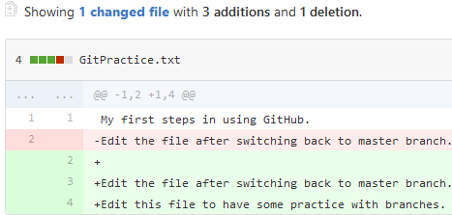

1. Practice_branch deleted

